DOVER GOLD STAR SHAWL
Designed by Cheryl Scallon
cvscallon@yahoo.com
St. Julie Billiart Shawl Ministry
Tinley Park, IL.
Are you interested in making Prayer Shawls 4 Fallen Soldiers' families?
Visit: http://webpages.charter.net/ps4fs/shawls/

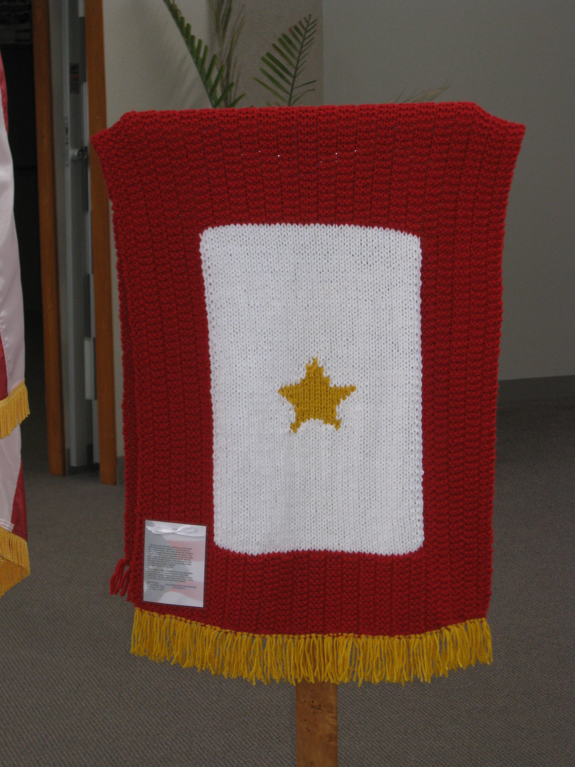

Materials: Plymouth Encore Chunky:
4 skeins red, # 9601
2 skeins white, #0208
Patons Canadiana – 1 skein, gold, #610
Needles: Size 13 US straight needles
Gauge: 12 sts, 24 rows + 4” over K3, P3 pattern stitch
14 sts, 18 rows = 4” over Stockinette stitch

Pattern Stitch:
Row 1: K3, P3, K3
Row 2: K3, P3, K3
Repeat Rows 1-2 for pattern

Shawl:
With red, cast on 69 sts. Work in pattern stitch for 30 rows.

Row 31: Work Pattern stitch (K3, P3, K3) across 15 stitches. Place marker. Join white. Knit across next 39 st to begin St st pattern. Place marker. Join red. Work Pattern Stitch (K3, P3, K3) across to end of row.

Row 32: In red, work Pattern Stitch (K3, P3, K3) to 1st marker (15 sts). In white, Purl next 39 sts to 2nd marker. In red, work Pattern Stitch to end of row.

Rows 33-60: Continue to work Pattern Stitch in red to form a 15 st border at the beginning and ending of each row and work St st for the center panel in white.

Rows 61: Maintain red (K3, P3, K3) across the first 15 sts, With white, knit across 12 sts. Place Marker. Work Gold Star Chart Pattern in St st over the next 15 sts. Place marker. K 12 in white. Work to end of row in red with the (K3, P3, K3) border as established.

Rows 62-80: Maintaining red borders in Pattern Stitch and white center panel in St st, work Gold Star Chart over center 15 sts.

Rows 81-110: Continue to work Pattern Stitch in red to form a 15 st border at the beginning and ending of each row and work St st for the center panel in white.

Row 111: Work the first 15 sts in Pattern Stitch. Drop white. With red, continue in Pattern Stitch (K3, P3, K3) across row, removing markers as you knit.

Continue to work Pattern Stitch across all rows until desired length. Bind off.

Finishing:
Cut 138 six inch strands of gold yarn. Using two strands held together, attach the gold fringe to the cast on row. Cut 69 six inch strands of red yarn. Using only one strand, attach the red fringe to the bind off row.

Notes…
To avoid a shortage of yarn, cut the fringe before you begin the last ball of red yarn.

The Gold Star is worked in intarsia. To prevent holes, when changing colors, it is important to always bring the new color under the color you have just finished using.

ABBREVIATIONS:
K = knit, P = purl, sts = stitch(es), St st = stockinette stitch (Knit one row, Purl one row).

Gold Star Chart:
Row 1: Place marker. K3 in white. Attach a double strand of gold. K1. Attach white. K 7. Attach a double strand of gold. K1. Attach white. K3. Place marker.
Row 2: P3 in white. P2 in gold. P5 in white. P2 in gold. P3 in white.
Row 3: K3 in white. K3 in gold. K3 in white. K3 in gold. K3 in white.
Row 4: P4 in white. P7 in gold. P4 in white.
Row 5: K4 in white. K7 in gold. K4 in white.
Row 6: P4 in white. P7 in gold. P4 in white.
Row 7: K4 in white. K7 in gold. K4 in white.
Row 8: P3 in white. P9 in gold. P3 in white.
Row 9: K2 in white. K11 in gold. K2 in white.
Row 10: P1 in white. P13. P1 in white.
Row 11: K15 in gold.
Row 12: P5 in white. P5 in gold. P5 in white.
Row 13: K5 in white. K5 in gold. K5 in white.
Row 14: P6 in white. P3 in gold. P6 in white.
Row 15: K6 in white. K3 in gold. K6 in white.
Row 16: P6 in white. P3 in gold. P6 in white.
Row 17: K7 in white. K1 in gold. K7 in gold.
Row 18: P7 in white. P1 in gold. P7 in white.

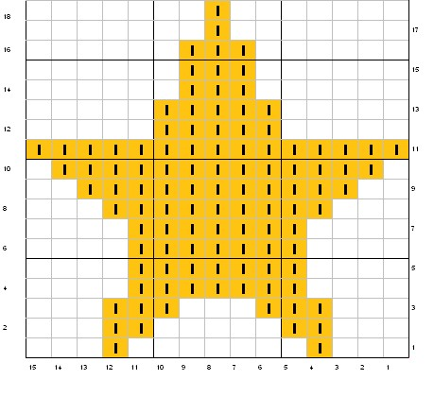
Meaning of the Gold Service Star
The Service Flag is an official banner authorized by the Department of Defense for display by families who have members serving in the Armed Forces during any period of war or hostilities the United States may be engaged in for the duration of such hostilities.
The history of the Service Flag is as patriotic and touching as the symbolism each star represents to the families that display them.
The service flag (also known as "blue star banners" or "son in service flags") was designed and patented by World War I Army Captain Robert L. Queissner of the 5th Ohio Infantry who had two sons serving on the front line. The flag quickly became the unofficial symbol of a child in service. President Wilson became part of its history when in 1918 he approved a suggestion made by the Women's Committee of the Council of National Defenses that mothers who had lost a child serving in the war to wear a gold gilt star on the traditional black mourning arm band.
This led to the tradition to cover the blue star with a gold star on the Service flag to indicate that the service member has died or been killed.
The color of the stars is also symbolic in that the blue star represents hope and pride and the gold star represents sacrifice to the cause of liberty and freedom. www.usflag.org/history/serviceflag

